**Unpacking of collections in python**

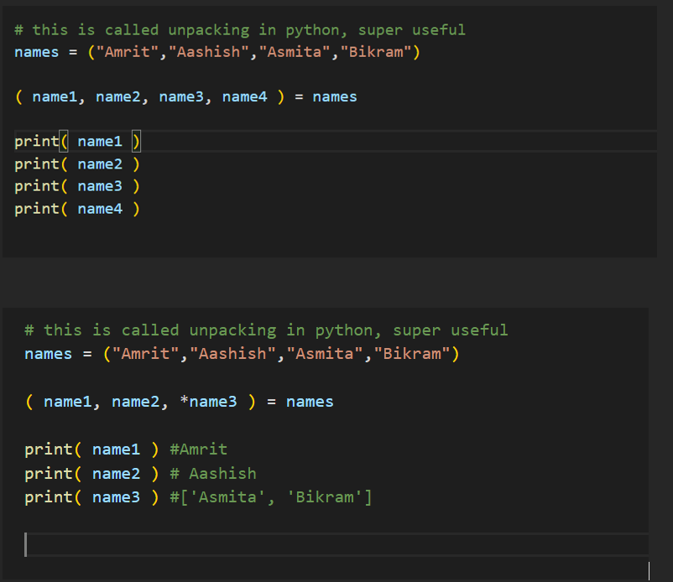

Super useful